Q.1 Write a short paragraph in your own words defining what a 'program' is and give one real-life example from any app you use daily (like Instagram, Zomato, or Paytm).
Ans. A program is a set of instructions written in a programming language that tells a computer or mobile device how to perform a particular task. Programs are used to perform different activities such as calculating numbers, storing information, displaying results, and processing user inputs. For example, the Zomato app uses many programs to help users search for nearby restaurants, view menus, select food items, place orders, make online payments, and track their delivery. All these tasks are performed with the help of programs running in the background.
Q.2 List three popular programming languages you have heard of, and for each, mention whether it is usually compiled, interpreted, or can be both.
ANS. Three popular programming languages,
- Java – It can be both compiled and interpreted. Java code is compiled into bytecode and then executed by the Java Virtual Machine (JVM).
- Python – It is usually interpreted. Python code is executed using an interpreter, which makes it easy to run and test.
- JavaScript – It is usually interpreted, but modern JavaScript engines also use compilation techniques to improve performance.
Therefore, Java can be both, while Python and JavaScript are generally considered interpreted languages.
Q.3 Draw a flowchart (on paper or using any online tool) for the process of booking a movie ticket on BookMyShow, starting from opening the app to receiving the booking confirmation.
ANS.
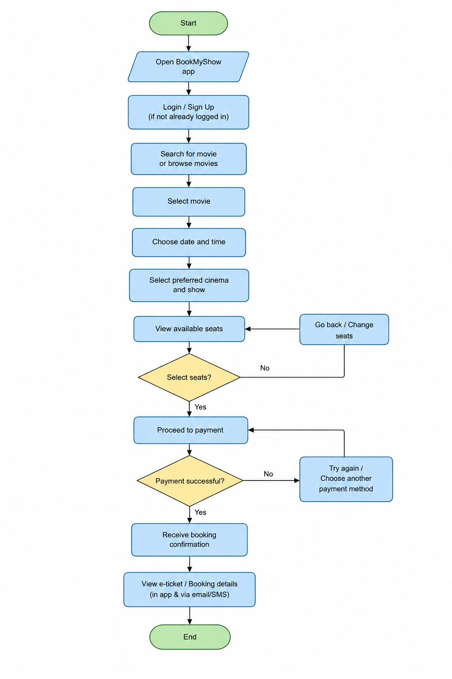

Q.4 Write down the steps (as an algorithm, using simple numbered instructions) for ordering food on Swiggy — from opening the app to completing payment.
ANS.
- Start the Swiggy app.
- Enter or select your delivery location.
- Search for a restaurant or food item.
- Select a restaurant from the list.
- Choose the food items you want to order.
- Add the selected items to the cart.
- Open the cart and check the order details.
- Confirm the delivery address.
- Select a payment method.
- Review the total order amount.
- Click on “Place Order” and complete the payment.
- After successful payment, the order is confirmed.
- Stop.

